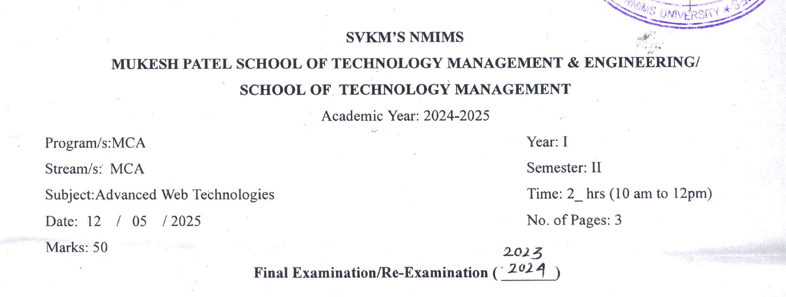

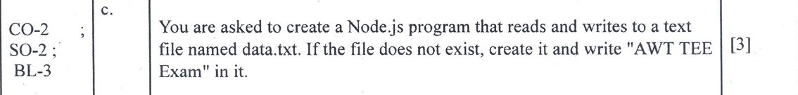
Server.js
var http = require('http');
var fs = require('fs');

var server = http.createServer(function(req, res){

fs.writeFile("data.txt", "AWT TEE Exam", function(err){
if (err) throw err;

console.log("File created"); // shows in terminal

res.writeHead(200, {'Content-Type':'text/html'}); // 200 for OK(Successful) and HTML for HTML type rendering
res.write("File created and data written successfully");
res.end();
});

});

server.listen(5000);
console.log("Server running at http://localhost:5000/");

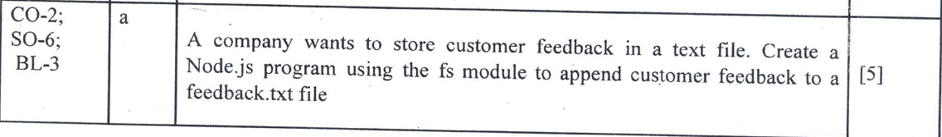

Feedback.js
var http = require('http');
var fs = require('fs');

var server = http.createServer(function(req, res){

var feedback = "Customer Feedback: Good Service\n";

fs.appendFile("feedback.txt", feedback, function(err){
if (err) throw err;

console.log("Feedback added");

res.writeHead(200, {'Content-Type':'text/html'});
res.write("Customer feedback stored successfully");
res.end();
});

});

server.listen(5000);
console.log("Server running at http://localhost:5000/");

Feedback.txt
hello, your feedback is submitted!
Output
hello, your feedback is submitted!AWT TEE ExamAWT TEE ExamCustomer Feedback: Good Service
Customer Feedback: Good Service


Promises.js
var fs = require('fs').promises;

// Writing to file
fs.writeFile("demo.txt", "Hello World\n")
.then(() => {
console.log("File written successfully");

// Appending to file
return fs.appendFile("demo.txt", "This is appended text\n");
})
.then(() => {
console.log("Data appended successfully");

// Reading file
return fs.readFile("demo.txt", "utf8");
})
.then((data) => {
console.log("File Content:\n" + data);
})
.catch((err) => {
console.log(err);
});

URLParsing.js
var http = require('http');
var url = require('url');

var server = http.createServer(function(req, res){

// parse URL
var q = url.parse(req.url, true);

var pathname = q.pathname;
var query = q.query;

res.writeHead(200, {'Content-Type': 'text/plain'});

// plain text response
res.write("Path: " + pathname + "\n");
res.write("Name: " + query.name + "\n");
res.write("Dept: " + query.dept);

res.end();
});

server.listen(5000);
console.log("Server running at http://localhost:5000/");

// http://localhost:5000/?name=abc&dept=cse

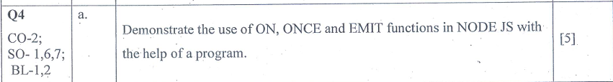
eventEmitter.js
var events = require('events');
var eventEmitter = new events.EventEmitter();

// using ON (can run multiple times)
eventEmitter.on('greet', function(){
console.log("Hello from ON function");
});

// using ONCE (runs only one time)
eventEmitter.once('greetOnce', function(){
console.log("Hello from ONCE function");
});

// using EMIT to trigger events
eventEmitter.emit('greet');
eventEmitter.emit('greet'); // runs again

eventEmitter.emit('greetOnce');
eventEmitter.emit('greetOnce'); // will NOT run again

//on() → listens to event, runs every time event is emitted
//once() → runs only first time
//emit() → triggers the event

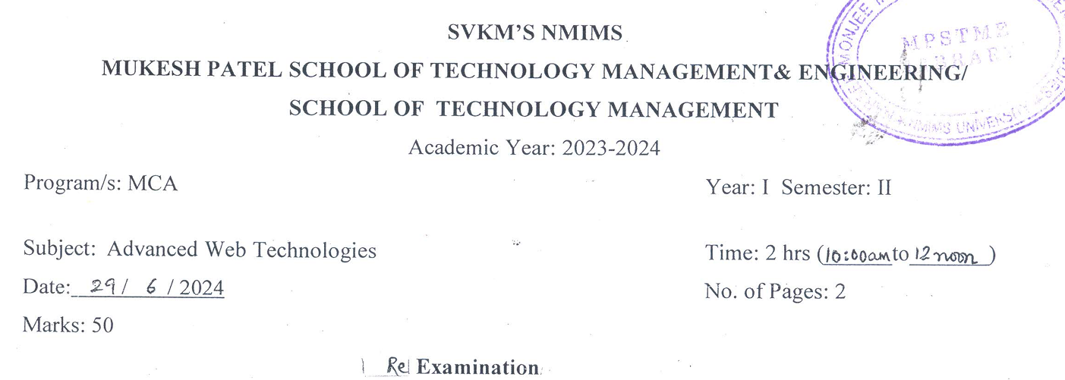
twoURL.js
var http = require('http');
var url = require('url');

var server = http.createServer(function(req, res){

var q = url.parse(req.url, true);
var path = q.pathname;

res.writeHead(200, {'Content-Type': 'text/html'});

// check URL paths
if(path == "/home"){
res.write("<h1>Welcome to Home Page</h1>");
}
else if(path == "/about"){
res.write("<h1>Welcome to About Page</h1>");
}
else{
res.write("<h1>Page Not Found</h1>");
}

res.end();
});

server.listen(5000);
console.log("Server running at http://localhost:5000/");

//http://localhost:5000/about
//http://localhost:5000/home



Error.js
var fs = require('fs');

fs.readFile("data1.txt", "utf8", function(err, data){

if (err) {
console.log("Error: File does not exist or cannot be accessed");
return;
}

console.log("File Content:");
console.log(data);

});

EXPERIMENT 8 (NODE.JS)
- Create a basic HTTP server in node js with http module
- Create a server that prints the URL requested by the client.
- Write a program that displays current date and time when the server is accessed.
- Build a simple calculator using URL parameters: Example: URL sent form browser is in the format: http://localhost:3000/?a=10&b=5
- Implement all the file operations using fs module
- Display file contents line by line on browser.

Task 1
const http = require('http');

const server = http.createServer((req, res) => {
res.write("Hello! Node.js Server Working");
res.end();
});

server.listen(3000, () => {
console.log("Server running at http://localhost:3000");
});

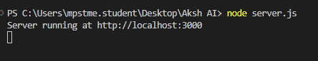
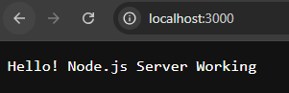
Task 2
const http = require('http');

http.createServer(function (req, res) {
res.write("Requested URL: " + req.url);
res.end();
}).listen(3000);

console.log("Server running at port 3000");

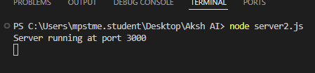
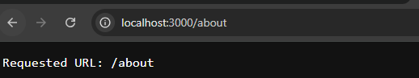

Task 3
const http = require('http');
const url = require('url');

http.createServer(function (req, res) {

const q = url.parse(req.url, true).query;

let a = parseInt(q.a);
let b = parseInt(q.b);

let sum = a + b;

res.write("A: " + a + "<br>");
res.write("B: " + b + "<br>");
res.write("Sum: " + sum);

res.end();

}).listen(3000);

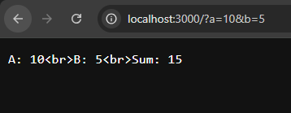
Task 4
const http = require('http');

http.createServer(function (req, res) {

const date = new Date();

res.write("Current Date and Time: " + date);
res.end();

}).listen(3000);

console.log("Server running...");

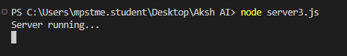
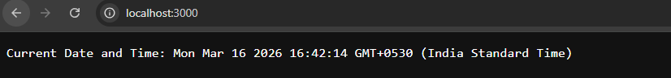
Task 5
const fs = require('fs');

fs.writeFile('demo.txt', 'Hello NodeJS', function (err) {
if (err) throw err;
console.log("File created");
});

fs.appendFile('demo.txt', '\nWelcome to FS module', function (err) {
if (err) throw err;
console.log("Data appended");
});

fs.readFile('demo.txt', 'utf8', function (err, data) {
if (err) throw err;
console.log(data);
});

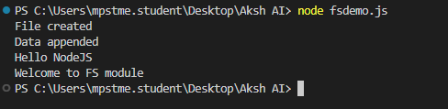
Task 6
const http = require('http');
const fs = require('fs');

http.createServer(function (req, res) {

fs.readFile('demo.txt', 'utf8', function (err, data) {

if (err) throw err;

const lines = data.split('\n');

lines.forEach(function (line) {
res.write(line + "<br>");
});

res.end();
});

}).listen(3000);

console.log("Server running...");

